Pharmaceutical Drug Sales Analysis
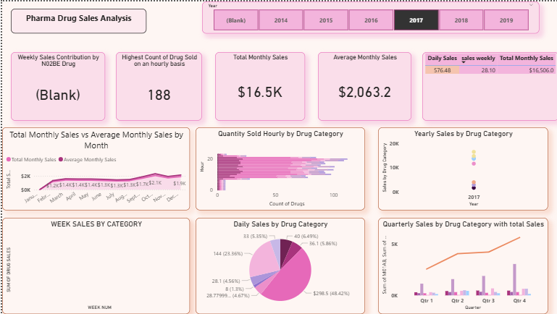
1. Project Overview
The Pharmaceutical Drug Sales Analysis project focuses on analyzing pharmaceutical sales data to identify sales trends, high-performing drug categories, demand patterns, and time-based variations in drug consumption.
The project uses Power BI to transform raw pharmaceutical sales data into an interactive analytical dashboard. The analysis covers sales performance at daily, weekly, monthly, quarterly, yearly, and hourly levels, enabling users to understand business performance and identify important sales patterns.
The project demonstrates practical Data Analytics skills including data preparation, data modeling, KPI development, time-series analysis, data visualization, and business insight generation.

2. Business Objective
The primary objectives of the project were to:
- Analyze overall pharmaceutical drug sales performance.
- Identify the contribution of different drug categories to total sales.
- Analyze weekly and monthly sales trends.
- Understand quarterly and yearly sales patterns.
- Identify hourly demand patterns.
- Compare actual monthly sales with average monthly sales.
- Identify the contribution of the N02BE drug category.
- Provide an interactive dashboard for business-oriented sales analysis.

3. Dataset
The Power BI model contains multiple levels of sales data:
Daily Sales Data
Used to analyze day-level pharmaceutical sales and category contribution.
Weekly Sales Data
Used to evaluate weekly sales trends and compare different drug categories across weeks.
Monthly Sales Data
Used for monthly, quarterly, and yearly sales analysis.
Hourly Sales Data
Used to understand how drug demand varies throughout the day.
The drug categories represented in the dashboard include:
- M01AB
- M01AE
- N02BA
- N02BE
- N05B
- N05C
- R03
- R06
A date hierarchy was used in Power BI to support analysis at Year → Quarter → Month levels.

4. Tools & Technologies
Power BI
- Data visualization
- Data modeling
- Interactive dashboard development
- KPI cards
- Slicers
- Time-series analysis
DAX
- Total Monthly Sales
- Average Monthly Sales
- Daily Sales
- Weekly Sales
- N02BE sales contribution
Data Analytics Techniques
- Trend analysis
- Category analysis
- Time-based analysis
- KPI analysis
- Comparative analysis

5. Data Preparation & Modeling
The data was organized into separate analytical tables for different time granularities, including daily, weekly, monthly, and hourly sales.
A date hierarchy was incorporated into the Power BI model to enable analysis across different periods.
The model supports:
Year → Quarter → Month → Week/Day/Hour
This structure allows users to drill down from high-level sales performance into more detailed time-based patterns.

6. Key KPIs
The dashboard includes important performance indicators such as:
Total Monthly Sales
Measures the overall sales generated during the selected period.
Average Monthly Sales
Provides the average sales level and acts as a benchmark for comparing individual months.
Weekly Sales Contribution by N02BE
Measures the contribution of the N02BE drug category to weekly sales.
Hourly Drug Sales
Measures drug demand at different hours of the day to identify peak demand periods.
These KPIs provide a quick overview of the pharmaceutical sales performance before users explore detailed visualizations.

7. Dashboard Analysis
The Power BI dashboard contains multiple visualizations designed to answer different business questions.
Weekly Sales by Drug Category
A column chart compares weekly sales across the different pharmaceutical categories.
This visualization helps identify:
- High-performing drug categories
- Changes in category demand across weeks
- Weekly fluctuations in sales
- Categories that consistently contribute to sales

Monthly Sales vs Average Monthly Sales
A time-series visualization compares Total Monthly Sales with Average Monthly Sales.
This enables users to:
- Identify months with above-average performance
- Detect periods of lower sales
- Understand overall sales movement
- Evaluate sales consistency over time

Hourly Quantity Sold by Drug Category
The hourly analysis evaluates drug quantities sold at different hours of the day.
This can help businesses understand:
- Peak demand periods
- Low-demand hours
- Category-specific demand patterns
- Potential opportunities for inventory and resource planning

Daily Sales by Drug Category
The category-level visualization shows the relative contribution of different pharmaceutical products to daily sales.
It helps identify which drug categories are major contributors to overall demand.

Yearly Sales by Drug Category
The yearly trend visualization provides a higher-level view of category performance over time.
It can be used to evaluate:
- Long-term growth or decline
- Changes in category contribution
- Consistency of demand
- Emerging high-performing categories

Quarterly Sales Analysis
The quarterly visualization combines individual drug-category sales with the Total Monthly Sales measure.
This allows comparison of sales performance across quarters and helps identify periods of stronger or weaker demand.

8. Interactive Dashboard Features
The dashboard includes a Year slicer, allowing users to filter the analysis dynamically.
When the selected year changes, the dashboard can be used to evaluate:
- Weekly sales
- Monthly sales
- Quarterly sales
- Yearly category performance
- Daily category contribution
- Hourly demand
- KPI values
This makes the dashboard useful for exploratory analysis rather than being a static report.

9. Key Business Insights
The analysis is designed to provide the following business insights:
- Drug categories contribute differently to overall sales, making category-level analysis important for understanding the sales mix.
- Sales vary across different time periods, highlighting the importance of monitoring weekly and monthly trends rather than relying only on aggregate sales.
- Hourly demand patterns can help identify peak selling periods, which can support better inventory and operational planning.
- Monthly sales can be compared against average performance to identify stronger and weaker sales periods.
- N02BE is specifically monitored through a dedicated KPI, indicating its importance in evaluating weekly sales contribution.
- Quarterly and yearly analysis provides a long-term perspective, allowing businesses to distinguish short-term fluctuations from broader sales trends.

10. Business Recommendations
Based on the analytical framework developed in the dashboard, pharmaceutical businesses can:
- Focus inventory planning on consistently high-demand drug categories.
- Monitor peak hourly demand to improve stock availability.
- Investigate months where sales fall significantly below the average.
- Track high-contributing drug categories separately.
- Use quarterly and yearly trends for demand forecasting and strategic planning.
- Regularly monitor the dashboard to identify changes in customer demand.

11. Project Workflow
The overall project workflow was:
Raw Sales Data
↓
Data Preparation & Cleaning
↓
Data Modeling
↓
DAX Measures & KPIs
↓
Time-Based Analysis
↓
Category Analysis
↓
Power BI Visualizations
↓
Interactive Dashboard
↓
Business Insights & Recommendations

12. Resume-Ready Project Description
Pharmaceutical Drug Sales Analysis | Power BI
- Developed an interactive Power BI dashboard to analyze pharmaceutical sales across daily, weekly, monthly, quarterly, yearly, and hourly dimensions.
- Built DAX-based KPIs including Total Monthly Sales, Average Monthly Sales, Daily Sales, Weekly Sales, and N02BE sales contribution.
- Analyzed sales performance across 8 pharmaceutical drug categories to identify category contribution, demand patterns, and time-based sales trends.
- Implemented date hierarchies and interactive year-level filtering to enable dynamic drill-down and comparative analysis.
- Generated business insights around sales trends, peak demand periods, category performance, and inventory planning opportunities.

